|  |
| --- |
| **Lesson plan** |

|  |  |  |  |  |
| --- | --- | --- | --- | --- |
| **Module:** | Marbles | | | |
| **Number of hours:** | 1 - 2 lessons | | | |
| **Vintage:** | 9th year of primary school | | | |
| **Short Description:** | By modelling a real situation, we get a first idea of a linear function. This is an increasing linear function whose domain is non-negative integers. In class, we will focus mainly on the covariation aspect of the concept of a function - the change in volume of a container as a function of the number of balls placed in it. Students will work with different representations of a function (table, graph, verbal description, possibly with a formula). | | | |
| **Principles of creation:** | **Research** |  |  |  |
| **Situatedness** |  |  |  |
| **Digital tools** |  |  |  |
| **Embodiment** |  |  |  |
| **Functional thinking:** | **Input - Output** |  |  |  |
| **Covariation** |  |  |  |
| **Correspondence** |  |  |  |
| **Object** |  |  |  |
| **Objectives:** | * Know how to enter values in a table and plot them on a graph * Know how to explain what affects the volume in a container * Recognize that the points of the graph lie on one line * Understand the meaning of the intersection with the y-axis in  a given context * Understand the meaning of the slope in particular context * Link different representations of the concept of function (table, graph, verbal description and formula) * Based on the table and graph, derive the function formula * Recognize that when generalizing the problem, it is necessary to consider the effect of initial conditions on the realism of the modelling situation (volume of water at the beginning, size of the marbles, dimensions of the cylinder-shaped container into which the marbles are dropped, etc.) * Knowing that a formula in the form of $y=kx+q$ has a function that is called a linear * Observe some properties of a linear function, e.g. the graph is a line or part of a line, if the coefficient $k$ in the function's formula is positive so the function is increasing, if it is negative so it is decreasing, identify constant rate of change of the function, determine "appropriate" function values to derive the formula, plot the graph | | | |

|  |
| --- |
| **Activities** |

Lesson 1

Engage

Activity 1

For several days the sun burned continuously and the whole country was parched. The weakened crow circled over the countryside, searching in vain for something to drink. She knew that if she didn't find water soon, she would die of thirst. When she had lost almost all hope, she descended to the ground. Her eyes were struck by an old cairn laid by a pile of pebbles. Crow walked slowly to it and peered into it curiously. There was water at the bottom of the crook. The crow eagerly stuck its head into the crook, but its beak was too short and it could not reach the water. She knew that if she knocked it over, the water would flow out and soak into the ground. At that moment, the crow thought of something. How do you think she managed to drink?

* *At the beginning of the lesson, divide the students into groups and give them worksheets. There are three students in each group (if necessary, we put four students in some groups).*
* *After reading the story together, each group of students formulates their suggestions and writes them on a worksheet.*

**Suggested aids, tools:**

* a worksheet for each student (we will use the worksheet throughout the lesson)

**Activity** 2

You have a measuring cylinder with 150 ml of water in it.

a) How many marked lines on the measuring cylinder correspond to 50 ml in the cylinder?   
b) How many ml is one marked line?   
c) If the level rises by marked lines, how many ml has it risen?   
d) At least how many marbles need to be dropped into the measuring cylinder for the level to rise by 50 ml? Estimate without dropping the marbles.

* *At the beginning of the activity, distribute a measuring cylinder to each group.*
* *The activity is aimed at familiarizing with the aids. Students should work out that 50ml is equivalent to 10 marked lines and therefore 1 marked line is 5ml and if the level rises by two marked lines it has risen by 10ml.*
* *In part (d), the group of students writes the estimate they agree on in the worksheets. It is possible that one of the students will use direct proportionality in the estimation.*
* *The first two activities are followed by a joint discussion. Students tell the teacher their ideas for activity 1. It is possible that someone will suggest that the crow throw pebbles into the jug. We can mention that this is Aesop's famous fable* ***The Crow and the Pitcher****, which has the following message: Destitute teaches a man how to cope.*
* *We will write the estimates of each group in activity 2(d) on the board so that we can evaluate them after the next activity.*

**Suggested aids, tools:**

* A measuring cylinder with a capacity of at least 300 ml and a diameter of approximately 5 cm,
* some glass marbles for the teacher, (the volume of 5 marbles must be 10 ml, if we have marbles with a different volume, we need to adjust the numerical values in the worksheets - in the tasks and activities.).

**Estimated time:** 10 minutes for Activity 1 and 2

Explore

Activity 3

Drop 5 marbles into a measuring cylinder containing 150 ml of water. Then write in the table the volume in ml in the measuring cylinder. Repeat the process - drop 5 marbles each time and write the volume in the table.

Plot the values you have obtained on a graph in the coordinate system.

|  |  |
| --- | --- |
| **Number of marbles in water** | **Volume in ml** |
| 0 |  |
| 5 |  |
| 10 |  |
| 15 |  |
| 20 |  |
| 25 |  |

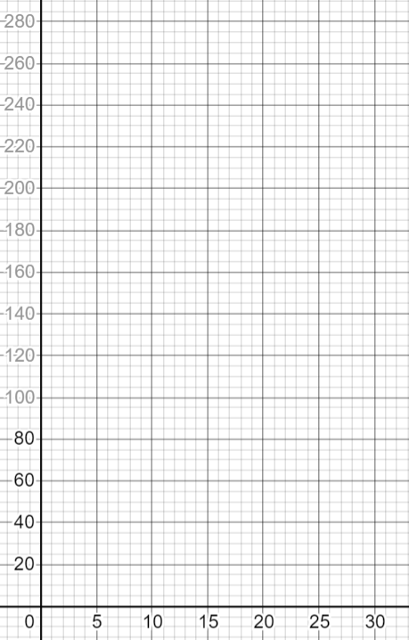

* *Each group carries out an experiment, fills in a table and plots the values on a graph.*

**Suggested aids, tools:**

* A measuring cylinder with a capacity of at least 300 ml with a diameter of approximately 5 cm,
* the same glass marbles in a number of 20 - 30 per group, (the volume of 5 marbles must be 10 ml, if we have marbles with a different volume, we need to adjust the numerical values in the worksheets - in the tasks and activities.) container for possible overflowing of water and storage of marbles,
* paper towels,
* worksheet.

Activity 4

Look at the graph and table you were given (in Activity 3). Write at least 3 different observations (either from the table or the graph).

* *Students can observe:*
  + *With five added marbles, our level rises by two pieces.*
  + *The level increases with the number of added marbles.*
  + *The individual points of the graph lie on a straight line.*
  + *The graph is rising.*
  + *The graph starts at the point with coordinates [0, 150].*

**Suggested aids, tools:**

* Worksheet

Activity 5   
a) Predict the volume in the measuring cylinder if a total of 35 marbles are thrown in.  
 b) What do you think will happen if another 15 marbles are thrown in?  
 c) How much will the volume in the measuring cylinder increase if we throw in one marble?  
 d) Complete the table:

|  |  |  |  |  |  |  |  |  |  |
| --- | --- | --- | --- | --- | --- | --- | --- | --- | --- |
| Number of marbles in water | 0 | 1 | 2 | 3 | 5 | 12 | 30 | 80 | x |
| Volume in ml |  |  |  |  |  |  |  |  |  |

e) What would change if we had 250 ml, 200 ml, 10 ml of water at the beginning*?*

f) What would change if we had bigger and smaller marbles at the beginning?

* *The expected answers are:*
  1. *With five marbles added, our level will rise by 10 ml, so at 35 it will be 7 times 10 ml, or 70 ml.*
  2. *If we add another 15 marbles, it will increase by another 30 ml.*
  3. *With five marbles added, our level rises by 10 ml, so one marble will raise the level by 2 ml.*
  4. $y=150+2x$*is the formula of the search function. However, its domain is from 0 to 75. This is because for a larger number of marbles, the whole marble is not submerged, so the generalization for 80 balls does not hold.*
  5. *Students should note that the formula changes the value of 150 to the new value of the initial volume. Some students might also realise the change in the domain and discuss how this will be the case for a volume of 10 ml. Is this volume too small?*
  6. *The volume of the marble affects the change in the coefficient at x. For example, if the volume of the marble is 3 ml, the coefficient will be 3.*

**Suggested aids, tools:**

* Worksheet

**Estimated time:** 25 minutes (together with Activity 3 and 4)

Explain

*Activity 5 is followed by a joint discussion of all groups and a comparison of the results of the problem solving sequentially from Activity 3 onwards. We also compare the estimate from Activity 2 with the actual value that the students got in Activity 3.*

*The teacher summarizes the students' observations on the board, refines the students' wording from Activity 4 (e.g., increasing function, not increasing, etc.), or adds pictures similar to the ones below to visualize the constant rate of change of the function:*

|  |  |
| --- | --- |
|  |  |

*It is possible that most groups will also enter a value for 80 marbles in the table in Activity 5. In that case, we can run the experiment in one measuring cylinder. We expect the students to work out for themselves that the volume of marbles cannot exceed the volume of water. This gives us the opportunity to discuss the notion of the domain of a function. The domain for our function is the set of natural numbers (including 0) up to 75, since there are 150 ml in the measuring cylinder and the volume of one marble is 2 ml.*

**Estimated time:** 10 minutes

Lesson 2

Elaborate and evaluate

Activity 6

What happens if we take the marbles out of a cylinder containing water and 50 submerged marbles? Try filling in the table and plotting the graph.   
 If you are not sure what it will look like, then carry out the experiment.

|  |  |  |  |  |  |  |  |  |
| --- | --- | --- | --- | --- | --- | --- | --- | --- |
| Number of marbles removed from the measuring cup | 0 | 5 | 10 | 15 | 20 | 25 | 50 | x |
| Volume in ml | 250 |  |  |  |  |  |  |  |

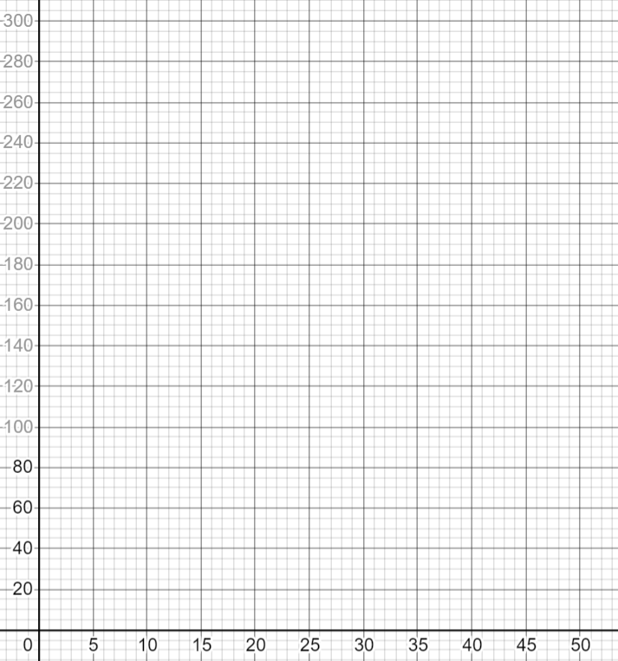

*It is a decreasing function in activity. We are looking to see if students can derive the formula and if they can also think about the domain of the function. The result is $y=250-2x$, where $x$ is a natural number from the interval $〈1, 50〉$* .

**Suggested aids, tools:**

* A measuring cylinder with a capacity of at least 300 ml and a diameter of approximately 5 cm,
* the same number of marbles 20-30 per group
* container for possible overflowing of water and storage of marbles
* paper towels,
* worksheet.

**Estimated time:** 10 minutes

Activity 7

Consider a situation where we have 200 ml of water in a measuring cylinder and we have larger marbles. With each ball thrown in, the volume now increases by 5 ml. Without throwing in the marbles, try to fill in the table.

|  |  |  |  |  |  |  |  |  |
| --- | --- | --- | --- | --- | --- | --- | --- | --- |
| Number of beads in water | 0 | 1 | 2 | 3 | 12 | 15 | 20 | x |
| Volume in ml |  |  |  |  |  |  |  |  |

Sketch a graph.

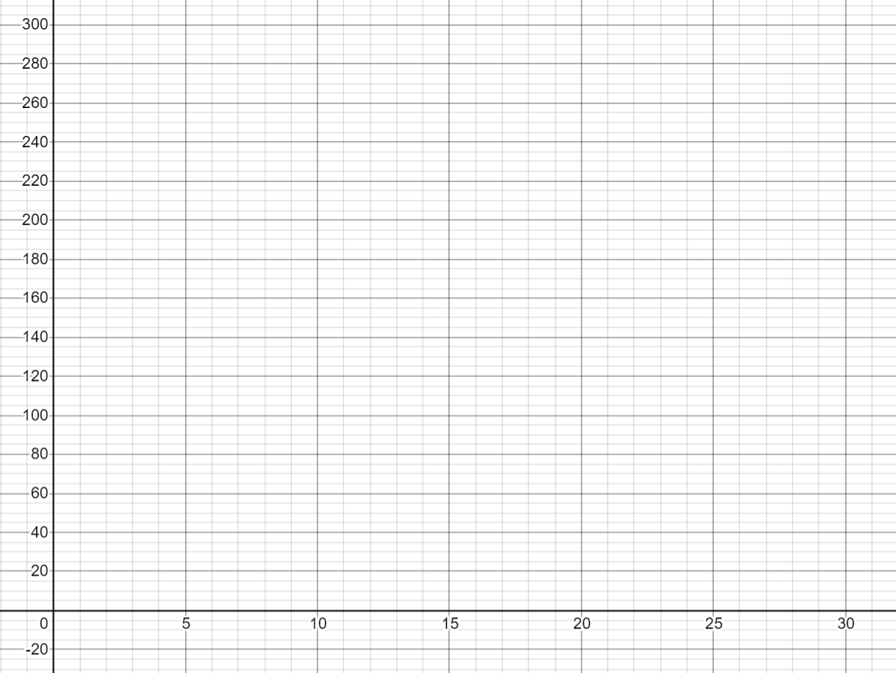

* *Unlike the previous activities, the students carry out the activity without aids. Students should notice that the function grows faster and the coefficient before x (the slope of the function) changes in the function formula. The resulting formula is $y=5x+200$.*

**Suggested aids, tools:**

* worksheet

**Estimated time:** 10 minutes

Explanation

Activity 8

In the left column of the table are the formulas you have encountered when working with marbles. In the right-hand column, write down what you have noticed within the formula.

|  |  |
| --- | --- |
| **Prescription** | **Observation** |
| $y=150+2x$ |  |
| $y=250+2x$ |  |
| $y=200+2x$ |  |
| $y=10+2x$ |  |
| $y=250-2x$ |  |
| $y=200+5x$ |  |

* *Students can write the properties of graphs in the observation (increasing, decreasing, points lying on a line, intersections with the y-axis or x-axis for a decreasing function, the domain of a function - described in their own words, the range of a function - described in their own words, etc.). Some groups may write down observations that are closely related to the context of the problem.*

Activity 9

Indicate what the formulas from the previous activity have in common.

* *We expect that some groups will notice that all the formulas are in the form of $y=q+kx$. It is natural for students to write the formula in a non-standard form (a reversed order of addends $kx$ a $q$)*
* *At this stage of the lesson, the teacher may informally introduce the concept of a linear function as a function whose formula is $y=kx+q$ (here the order of the addends can be $kx$ a $q$ be interchanged as is usual in textbooks, with the teacher referring to the commutative law of addition).*

Activity 10

a) Choose a criterion to divide the formulas from the activity 8 into groups. Write down this criterion.  
b) According to the criterion you have chosen, divide the formulas into groups.

*Students can choose the following criteria:*

* *Intersection with the y-axis (can be formulated by the students e.g. "according to the first number in the formula" )*
* *Slope (formulated by students as "by the number at x")*

*The activity will allow the teacher to discuss with the students what we can infer from the function formula about the properties of graphs. If the students do not observe the properties listed, it is not necessary to conclude during this lesson.*

**Suggested aids, tools** (for activities 8 to 10)**:**

* worksheet

**Estimated time:** 15 minutes

Activity 11

Guess the function formula.

* *We will play the game if we have enough time in class.*
* *The teacher thinks of a formula of a linear function and the students' task is to guess this formula.*
* *We write the values of x on the board, which are chosen by the students, and the teacher then adds the calculated value of y.*

*The flow of the game on the board may look like the picture below. The object of the game is to fill in the formula in the yellow box based on the values found.*

|  |  |  |  |
| --- | --- | --- | --- |
| *x* | *1* | *50* | *...* |
|  | *2* | *149* | *...* |

* *Students can discover the following features during the game:*
  + *it is advantageous to give the teacher x=0 (we find the value of q)*
  + *just enter two numbers for one prescription*
  + *it is preferred that the second number chosen is 1*
* *We suggest choosing linear functions that have different properties (absolute term is positive, negative or 0, directive is a positive number, negative number, 0, number less than 1, fraction, decimal) Below are examples of possible formulas of linear functions:*

$y=2x, y=x+5,$ $y=2x+3, y=-2x-3, y=-10x+5, y=1000x+658, y=500x-341, y=-100x+92, y=\frac{1}{2}x-3,$ $y=-9x+\frac{2}{5}, y=\frac{1}{100}x+\frac{9}{10}$

**Estimated time:** 10 minutes