Module: Distance - Time Version A

Exploration
Use the app Desmos 1 on your tablet. Draw lines and select “Play” to observe the journey of the turtle. (The dashed line shows where the turtle’s noise is)
Select one of your sketches, draw it below and describe the respective journey of the turtle.
 | …………………………………………………………….  …………………………………………………………….  …………………………………………………………….  …………………………………………………………….  …………………………………………………………….  …………………………………………………………….  …………………………………………………………….

Activity 1
Use the app Desmos 2 on your tablet.
- Before selecting “Play”, use the graph to make a hypothesis about the journey of the turtle.
………………………………………………………………………………………………………………………………………………………………………………………………………………………………………………………………………………………………………………………………………………………………………………………………………………………………………………Select “Play” and describe again the journey of the turtle. ……………………………………………………………………………………………………………………………………………………………………………………………………………………………………………………………………………………………………………………………………………………………………………………………………………………………………………………………………………………………………………………………………………………………………………………………………………………………………………………

Activity 2
Fill in the table below either by sketching the graph or describing the journey of the turtle.
1 |  | Scenario  The turtle moves away from the water. Then, suddenly the turtle makes a short break and continues to walk away from the water.
2 |  | Scenario  The turtle moves away from the water. Then, suddenly the turtle makes a short break and returns back to the water. Before reaching the water, the turtle decides to walk away from the water.
3 |  | Scenario  The water walks away from the water 8 ft in 4 seconds. The turtle makes a stop for 2 seconds. Then, the turtle returns to the water in 2 seconds.
4 |  | Scenario  The turtle is 4 ft away from the water. The turtle moves away from the water 2 ft in the next 4 seconds. Then, the turtle returns to the water walking 2 ft per second.
5 | 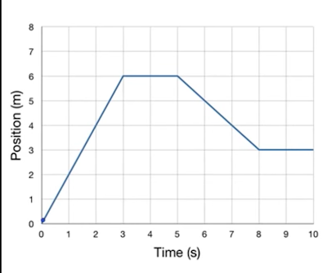 | …………………………………………………………….  …………………………………………………………….  …………………………………………………………….  …………………………………………………………….  …………………………………………………………….  …………………………………………………………….  …………………………………………………………….
6 | 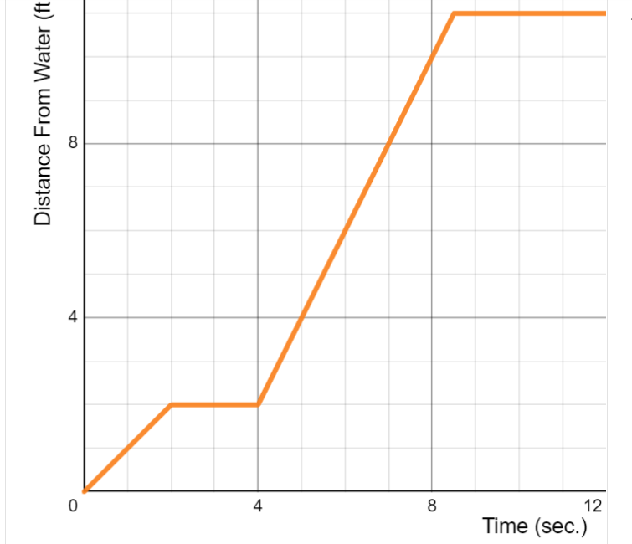 | …………………………………………………………….  …………………………………………………………….  …………………………………………………………….  …………………………………………………………….  …………………………………………………………….  …………………………………………………………….  …………………………………………………………….

Activity 3
Ami and Karen were hiking on a linear trail. The graph below shows the two hikers’ distance from the starting position over time.
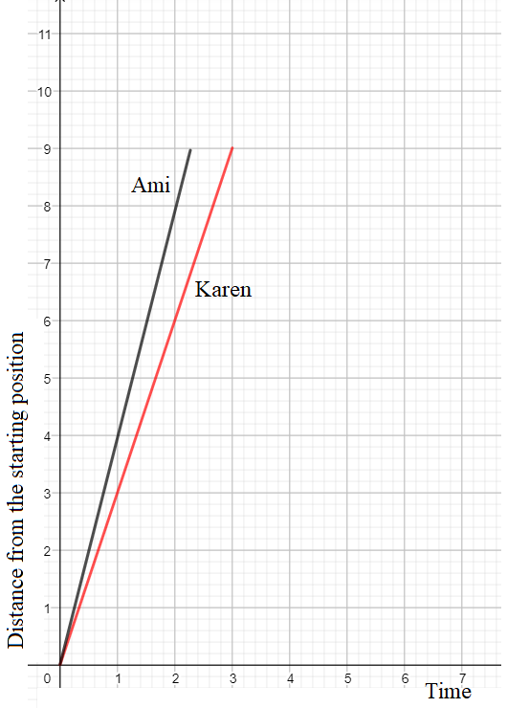
- How much distance each hiker covered during the first hour?
………………………………………………………………………………………………………………………………………………………………………………………………………………………………………………………………………………………………………………………………………………………………………………………………………………………………………………………………………………………
- Express the relationship of the distance from the starting position over time for each hiker.
………………………………………………………………………………………………………………………………………………………………………………………………………………………………………………………………………………………………………………………………………………………………………………………………………………………………………………………………………………………

Activity 4

Draw a graph that corresponds to the following description:
Julia used her skateboard to travel from her house to her friend’s house. They studied together and when they finished, she returned back home using her skateboard. On the way home, she made a stop to buy ice-cream.

Distance from Julia’s house

Time
Απόσταση από το σπίτι της Ιουλίας
Χρόνος

Time (in seconds)

Practice:

- Chris and Zoe were also hiking on a trail. The graph below shows the two hikers’ distance from the starting position over time.
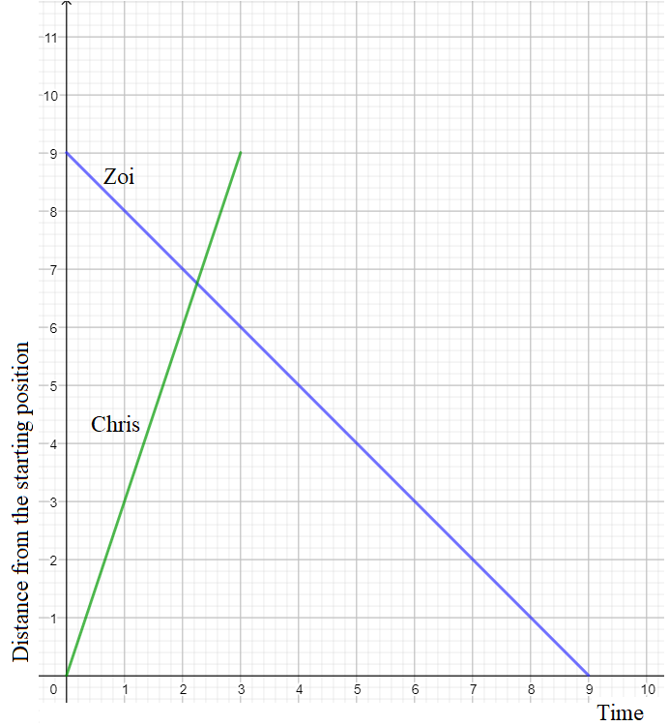
- Describe in what ways the two hikers’ motion was different.

- How much distance each hiker covered during the first hour?

- How much distance each hiker covered per hour?

- Express the relationship of the distance from the starting
position over time for each hiker.

Extension Activities:

- Draw graphs for the following situations using a grid or a software application. Name the x-axis and the y-axis.
  - Andi ran out of the classroom door, then slipped and fell. He then got up and walked to his home.

  - Panos was cycling slowly as he was climbing up the hill just outside his home and then cycled rapidly down the hill to enter his school.

  - Julia used her skateboard to go from her house to her friend’s house. They studied together and then used her skateboard to return to her house.

- Create a story and a distance-time graph about your journey to school.

Assessment Activities:

- Use the data in the following table to sketch a graph (on a grid or a software application) to show Anna’s walking journey from her house to the gym.

Distance (metres) | Time (minutes)
500 | 5
1000 | 10
1500 | 15
2000 | 20

- (a) John runs 8 km per hour at a constant speed. How many kilometers will he cover in three hours?

(b) Express the relationship between distance and time.

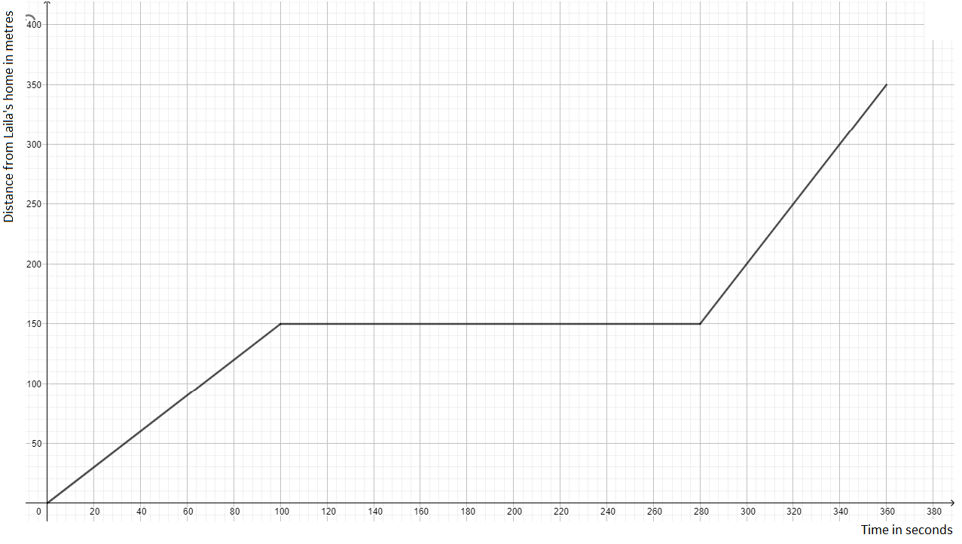
- Laila walks from her home to her grandmother’s house using a straight path, a distance of 350 meters. For each of the following graphs describe her journey.

……………………………………………………………………………………………………………………………………………………………………………………………………………………………………………………………………………………………………………………………………………………………………………………………………………………………………………………………………………………………………………………………………………………………………………………………………………………………………………………………………………………………………………………………………………..



