## FUNTHINK TEACHER MANUAL PRIMARY EDUCATION

## MODULE 2: FUNCTIONAL THINKING IN DISTANCE-TIME SCENARIOS

**Overall learning objectives** of primary school / teacher education:

### Quantitative reasoning:

#### What are the quantities that vary?

* + How do the quantities co-vary?
  + How do they correspond?
  + Object view

1. **Representations of functions (adaptive expertise/fluency)**
   * Moving between representations (table/graph/numbers/map/story)
   * Linking representation and situation

These learning objectives come to the fore in three modules:

1. Variation-co-variation
2. Distance-time graphs
3. Patterns

Each of these modules consists of a learning trajectory with the following characteristics:

Students:

* ...experience covarying quantities
* ...identify co-varying quantities; track them
* ...explain how they relate
* ...describe the correspondence

Key principles with each of these modules are variables, relationships and generalization; key processes are noticing, describing, justifying, representing, generalizing, reflecting and applying.

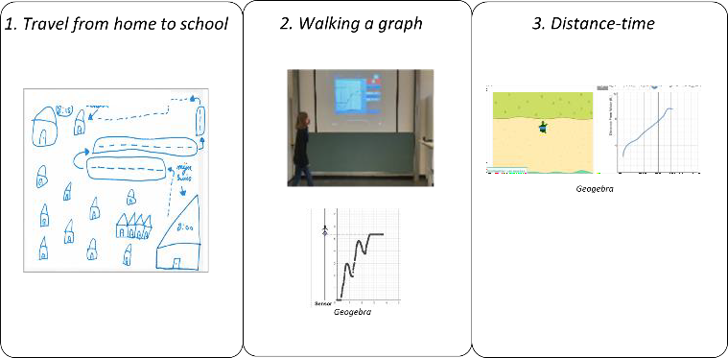In this document you can find the teacher manual of **Module 2: Functional thinking in distance-time scenarios**. This module consists of three main activities:

#### Travel from home to school

1. Walking in front of a motion sensor and produce distance-time graphs
2. Explore the relationship between distance-time graphs and movement in a digital environment

**Lesson Plan Module 2**

|  |  |  |  |  |
| --- | --- | --- | --- | --- |
| **Module:** | Functional thinking in distance-time scenarios | | | |
| **Teaching Hours:** | 2x 60 min (individual activities, whole class) or 1 x 120 min (circuit) | | | |
| **Grade Level/Age Range:** | 4-6 (9-12 years old) | | | |
| **Brief Description:** | In this module, students investigate distance-time graphs. They first create a graph of their own journey from home to school. Then they use real-world experiments and the Desmos applet "walking graphs digitally".  Understanding of graphs is enhanced by directly linking a physical experience (motion) to visually perceivable information in the graph (slope, position, direction). The "walking a graph" situation describes the relationship between the distance to a fixed point/sensor and the time it takes to complete a movement. Students experience this situation through walking to and form an ultrasonic sensor in the classroom and in a digital environment using Desmos.  The focus of this module is on developing and promoting a qualitative understanding of functional relationships.  The module engages students with the relationship between distance and time, exploring the graphical representation and the rate of change in distance-time scenarios. | | | |
| **Design Principles:** | **Inquiry** |  |  |  |
| **Situatedness** |  |  |  |
| **Digital tools** |  |  |  |
| **Embodiment** |  |  |  |
|  | * Inquiry based learning: Students explore and find out which movements create which kinds of graphs; Students find out how the content of a graph relates to their own movement or that of the turtle; * Situatedness: Students see a direct representation of their own movement (or the movement of the turtle); * Digital: transfer from physical activities to a digital activity, from a motion sensor to an application on a computer * Embodiment: Students connect their own physical movement (or the turtle’s movement) to a formal representation of distance- time graphs. | | | |
| **Functional Thinking:** | **Input – Output** |  |  |  |
| **Covariation** |  |  |  |
| **Correspondence** |  |  |  |
| **Object** |  |  |  |

|  |  |
| --- | --- |
| **Learning Goals:** | * Students learn to identify and name the quantities that vary in given scenarios * Students learn how to express and coordinate the co-variation of two quantities * Students learn to identify and represent (verbally, symbolically, and graphically) the correspondence relation between two quantities * Students learn to create and interpret graphs of functional relations * Students learn to generalize (verbally and symbolically) the correspondence relation between two quantities * Students learn to use functional expressions to model real-life scenarios |

**Activities**

### Activity 1.

**Travel from home to school**

This introductory activity requires the whole class to participate.

### Introduction

The teacher discusses the modes of transport students use to come to school.

After this whole class conversation, the teacher asks the students to schematically represent their travel from home to school in such a way that someone else could understand what happened. The students can use drawings, graphs, and text in their representation. The teacher asks questions to guide the students:

* *What information is important to include?*
* *What are important moments in your travel to school?*
* *What information is necessary for other people to understand/reconstruct your journey?*

### Suggested tools/materials/:

#### Paper

* (colored) Pencils or markers

**Estimated duration:** 10 minutes

### Whole classroom reflection

The teacher discusses the produced representations with students. The teacher asks the question: “What do the different representations tell us about the journey and what does it not show”? The teacher can ask follow-up questions like:

* *What else do we need to understand the representation of the journey?*
* *Did other students include this information?*
* *What can we learn when we compare the different representations?*
* *What variables did you include? (Time or distance?)*
* *Would it be possible to represent your travel on a straight line (axis)?*

**Estimated duration**: 10 minutes

### Activity 2.

**2a. Walking a graph**

This activity can be performed by the whole class or a part of the class. If the activity is performed in a circuit, the other part of the class will perform activity 2b first.

**Step 1.** The teacher introduces the activity by asking one of the students to come to move in front of the sensor (walking forward/backward, standing in one position …). The movement of the student is recorded with the help of a motion sensor and immediately displayed in a graph on the projection screen. The teacher guides and asks questions:

* *How do the graph and the movement correspond?*
* *Can you walk a pattern (e.g., zigzag)?*

**Step 2.** The teacher divides the students into small groups. Each group gets two or three example graphs. Students are asked to start with one of the three graphs and to devise a ‘walking plan’ for walking the depicted graphs. The teacher tells the students that the walking plan should be written so that anyone else would be able to recreate this specific graph. Then the students are asked to walk according to the plan in front of the sensor, to check if their description matches the first example graph. The teacher guides and asks questions:

* + *Does the produced graph look similar to the first example graph?*
  + *What are the differences and why are there differences?*
  + *How can you adjust your walking in such a way that the graph becomes more similar to the example, and why?*

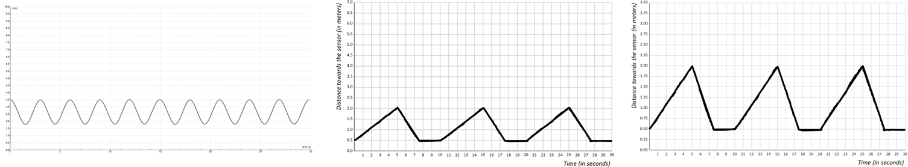

**Step 3.** The teacher shows the remaining two graphs and asks the students to describe the graph and the corresponding movement.

**Step 4.** The students are asked to draw a graph themselves and to recreate this graph by walking in front of the motion sensor.

### Suggested tools/materials/:

* Laptop(s) with Coach 7 software (lite version freely available via: [https://cma-science.nl/coach- 7-lite_en](https://cma-science.nl/coach-7-lite_en))
* Sensor(s)
* Example graphs

**Estimated duration:** 40 minutes

# Activity 2b: Explore distance-time with the Desmos app (turtle)

### Introduction

The teacher opens the Desmos app draws a graph and shows the corresponding movement of the turtle. The teacher asks the students to describe the movement in words. The teacher discusses what kind of quantities are incorporated in the descriptions.

### Exploration

The students work in pairs on the Desmos app on their devices (preferably tablets), as shown below:

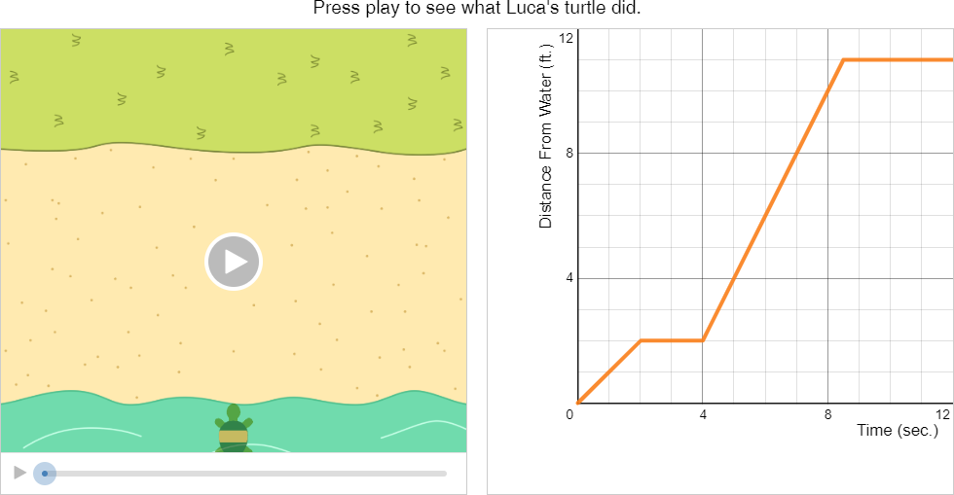

Students are asked to draw different sketches and describe how the turtle moves by playing the video.

The teacher guides the exploration of the students:

* *Draw points and describe the position of the turtle;*
* *Draw different sketches and describe how the turtle moves;*
* *Draw a line sketch and observe the turtle’s journey. Draw a steeper line, how does the turtle’s* journey change?
* *Draw line sketches that start from different points on the y-axis and observe the turtle’s journey. How does the turtle’s journey change?*

The teacher can also guide the students by asking questions (e.g.):

* *What quantities are shown on the two axes?*
* *How does the turtle's journey change?*
* *How does the movement of the turtle relate to a change in the graph?*
* *Can you make a hypothesis about the turtle’s journey based on the graph?*
* *Can you cover the graph and make a hypothesis of the graph based on the turtle’s journey?*

### Suggested tools/materials/:

#### Tablet devices

* Desmos app
* EN:https://teacher.desmos.com/activitybuilder/custom/5ddbf9ae009cd90bcdeaadd7?la ng=nl&collections=featured- collections%2C5da6476150c0c36a0caf8ffb#preview/8809fa03-a71e-45d9-b2cd- bef8ee337602
* NL:https://teacher.desmos.com/activitybuilder/custom/5fadcd24785f5f384d942088?la ng=nl&collections=featured- collections%2C5fadcd14a8b53c39e12bdc89#preview/8809fa03-a71e-45d9-b2cd- bef8ee337602

**Estimated duration:** 40 minutes

### Activity 3.

**Reflection + assessment activities**

The teacher reflects on the activities by asking the students: ‘If you would have to tell at home what you did in class today, what would you tell?’ The teacher asks deepening questions based on the answers of the children and lets them tell what they have learned during these activities.

The teacher can also provide the students with two assessment activities, to test the current understanding of functional thinking in distance-time scenarios. See the items on the next pages.

All assessment activities are derived from the study of Duijzer (2020).

Duijzer, C. (2020). *Moving towards understanding: Reasoning about graphs in primary mathematics education* [Doctoral dissertation, Utrecht University]. Utrecht University Repository. <https://dspace.library.uu.nl/handle/1874/398915>

**Estimated duration:** 20 minutes

**ASSESSMENT ITEMS**

### A car drive.

#### A car drives through town:

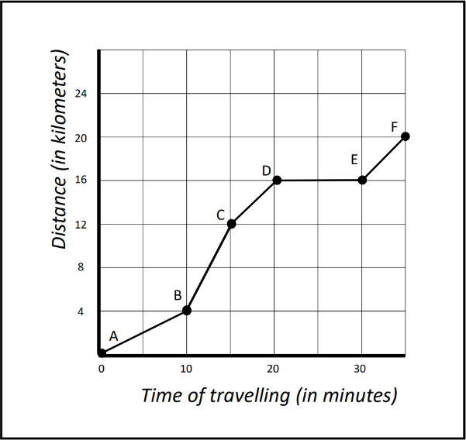

**Between which points does the car goes fastest? How do you know?**

* 1. **A train ride.**

A train travels **twice as fast** between **10:00 and 11:00** than between **11:00 and 12:00**. The train stands still from **12:00 to 13:00.**

#### Draw a graph that fits the description above. How do you know?

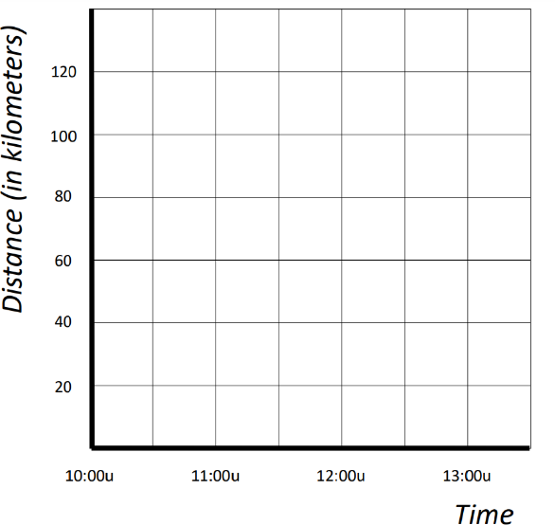

**Possible correct answer:**

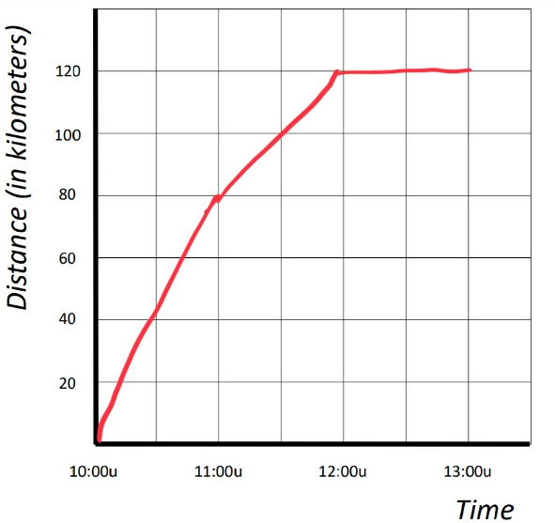

**Scoring**

1. **A car drive.**

Levels of reasoning with increasing sophistication:

R0: unrelated reasoning

R1: Iconic reasoning

R2: Single variable reasoning

R3: Multiple variable reasoning

### A train ride.

#### Levels of reasoning with increasing sophistication (based on the graphical solutions)

R0: an illogical graph without taking into account the description of the motion situation

R1: A graph based on superficial characteristics of the motion event

R2: A graph taking into account a single variable correctly

R3: A graph taking into account multiple variables correctly

